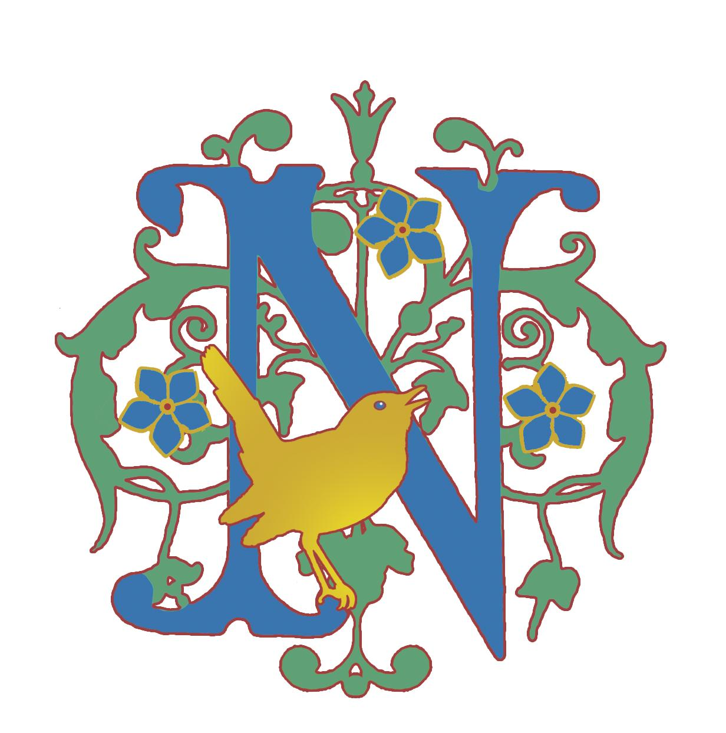

We are always on the look out for local professionals, specialist teachers or enthusiastic hobbyists to come in and provide us with unique learning experiences!

So far we have worked with a:

- Artist
- Photographer
- Bee keeper
- Financial Consultant
- Business Consultant
- Eco-artist
- Musician/ audio artist
- Doctor
- Prosthetic make up artist

and are hoping to expand this list!

If you think you have an interesting skill or passion to offer, please email nightingaleckent@gmail.com.

We are open Mondays 10 am – 2 pm and based in Shipbourne, TN11 9PA.

